

DISCONTINUATION ALERT

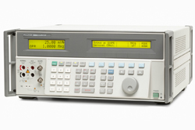
Last time buy announcement
for the 5500A/5500E Multiproduct Calibrators

Date: February 4th, 2013

Fluke is announcing a last time buy for the 5500A/5500E Multi Product Calibrators
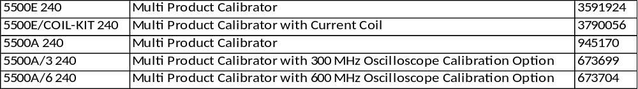
The last order date will be March 31st, 2013.
Please also note that orders will be accepted on a first come basis as long as stock lasts.
The new 5502A/5502E MultiProduct Calibrators replace the 5500A/5500E in this market place and can be considered as viable and improved replacement models.
Plan of Action:
We need your help to make this end of life notification go smoothly as we collect all remaining 5500A/5500E orders. Here is how you can help:

- Contact your 5500A calibrator customers and inform them of the end of life on April 1st, 2013. Especially for 5500A/5500E users with Met/Cal software and procedures written around the 5500A, now is the time to buy one the last 5500A’s available
- All units will have their normal warranty and come with an accredited calibration report.
- Assure customers that as per Fluke’s policy full service and repair of these calibrators will continue for at least five years after production ceases,
- Calibration services will continue indefinitely beyond that time.

- Future requirements for this class of calibrators will be satisfied by the new Fluke 5502A/5502E series of MultiProduct calibrators.
- We have prepared an html mail (see copy attached). In case you need this in your local language please contact gerda.meijer@fluke.nl

As only a limited number of units are available, we are willing to support you in closing the deal with your customer. Please contact us for further information.
Thank you for your assistance, good luck and successful selling

Joost Korthout / Lawrence Rainbird
Regional Product Marketing Managers

